Artificial Intelligence (AI)
Definition:
Artificial Intelligence (AI) is the field of computer science that focuses on creating machines or systems that can simulate human intelligence processes such as learning, reasoning, and problem-solving.
Key Abilities of AI:
- Understanding natural language
- Recognizing patterns and images
- Making decisions
- Learning from data
- Problem-solving

🌿 Branches of AI
Branch | Description | Example
Machine Learning (ML) | Enables systems to learn and improve from experience without being explicitly programmed. | Email spam filters
Natural Language Processing (NLP) | Helps machines understand and respond to human language. | Chatbots like Siri, Google Assistant
Computer Vision | Enables computers to interpret and understand visual information. | Face recognition on phones
Robotics | Designs and creates robots that can perform tasks autonomously. | Self-driving cars, factory robots
Expert Systems | Mimic decision-making abilities of a human expert. | Medical diagnosis systems
Fuzzy Logic | Deals with reasoning that is approximate rather than fixed. | Climate control systems

🚀 Applications of AI
- Healthcare: Diagnosis, drug discovery, medical imaging
- Finance: Fraud detection, trading algorithms, credit scoring
- Education: Intelligent tutoring systems, personalized learning
- Transportation: Self-driving cars, traffic predictions
- E-commerce: Recommendation engines (Amazon, Netflix)
- Agriculture: Crop health monitoring, predictive analytics

🤖 Machine Learning (ML)
Definition:
Machine Learning is a subset of AI that enables systems to automatically learn from data, identify patterns, and make decisions with minimal human intervention.

Types of Machine Learning and Their Algorithms

✅ 1. Supervised Learning
🔍 Definition:
Supervised learning is a type of machine learning where the model is trained on a labeled dataset—meaning both the input data (X) and the correct output (Y) are provided.
The goal is to learn a function that maps input to output, so the model can predict Y for new X.
📚 How it Works:
- Provide input and correct output during training.
- The algorithm learns the relationship.
- Evaluate with test data.
- Predict output for new input.

⚙️ Supervised Learning Algorithms
Algorithm | Type | How It Works | Example
Linear Regression | Regression | Finds the best-fit line through data points to predict continuous values. | Predicting house prices based on size and location.
Logistic Regression | Classification | Uses a sigmoid function to classify inputs into two categories (e.g., 0 or 1). | Predicting if an email is spam or not.
Decision Tree | Both | Breaks data into branches based on feature values to make a decision. Easy to interpret. | Loan approval system.
Random Forest | Both | Combines multiple decision trees for more accurate and stable predictions. | Predicting product sales in e-commerce.
Support Vector Machine (SVM) | Classification | Finds the optimal line (hyperplane) that separates data classes. | Face recognition or handwritten digit classification.
K-Nearest Neighbors (KNN) | Classification | Compares new data points with its closest neighbors and chooses the most common class. | Identifying disease based on symptoms.
Neural Networks | Both | Mimics the human brain using layers of "neurons" that learn complex patterns. | Speech recognition, image classification.

🧠 Supervised Learning Use Cases:
- Predicting student performance
- Diagnosing diseases from lab results
- Sentiment analysis in text
- Stock price forecasting

🧩 2. Unsupervised Learning
🔍 Definition:
Unsupervised learning is used when the dataset has no labels—only input data.
The algorithm tries to discover patterns, groupings, or hidden structures in the data.
📚 How it Works:
- No predefined labels or outcomes.
- The algorithm finds similarities or structures in the data.
- Mainly used for exploratory data analysis.

⚙️ Unsupervised Learning Algorithms (with Details)
Algorithm | Purpose | How It Works | Example
K-Means Clustering | Clustering | Divides data into K groups (clusters) by minimizing the distance between points and cluster centers. | Grouping customers by shopping behavior.
Hierarchical Clustering | Clustering | Creates a tree-like structure (dendrogram) to represent nested groupings of data. | Gene expression analysis in biology.
DBSCAN | Clustering | Groups data based on density. Detects outliers and clusters of varying shapes. | Detecting network intrusions.
PCA (Principal Component Analysis) | Dimensionality Reduction | Reduces high-dimensional data into fewer features by capturing maximum variance. | Compressing large image files.
Autoencoders (Neural Networks) | Pattern Learning | Learns to compress and then reconstruct input data, useful for unsupervised feature learning. | Image noise removal, anomaly detection.

🧠 Unsupervised Learning Use Cases:
- Customer segmentation
- Grouping similar news articles
- Anomaly detection in bank transactions
- Reducing features for visualization

🎮 3. Reinforcement Learning
🔍 Definition:
Reinforcement Learning is a type of machine learning where an agent learns to make decisions by interacting with an environment. It receives rewards for correct actions and penalties for wrong actions.
📚 How it Works:
- The agent observes the state of the environment.
- It takes an action.
- The environment provides a reward (positive/negative).
- The agent updates its strategy to maximize cumulative reward over time.

⚙️ Reinforcement Learning Algorithms (with Details)
Algorithm | Method | How It Works | Example
Q-Learning | Value-Based | Learns the best action to take in each state using a Q-table. | Robot learning to avoid obstacles.
SARSA | Value-Based | Similar to Q-learning but updates based on the actual action taken. | Pathfinding in maps.
Deep Q-Network (DQN) | Deep RL | Combines Q-learning with deep neural networks to handle large or continuous state spaces. | Game AI (like Atari or Dota 2).
Policy Gradient | Policy-Based | Learns the best strategy directly by optimizing the policy. Good for complex action spaces. | Humanoid robot movement.
Actor-Critic | Hybrid | Combines value-based and policy-based approaches. Learns both value function and policy. | Advanced robotics and simulations.

🧠 Reinforcement Learning Use Cases:
- Autonomous vehicles
- Game-playing agents (AlphaGo, Chess)
- Real-time strategy planning
- Smart traffic control systems

🔍 AI Agent
📘 Definition:
An AI agent is any entity (software or robot) that:
Perceives its environment through sensors, thinks/decides using logic or learning, and acts upon the environment using actuators or outputs to achieve specific goals.
The concept of an AI agent comes from agent-based systems in artificial intelligence and is a foundation for building intelligent behavior in machines.

🧠 Core Components of an AI Agent
Component | Description | Example
Sensors (Perception) | Devices or methods for collecting data from the environment. | Cameras, microphones, GPS, LIDAR
Actuators (Action) | Mechanisms that allow the agent to affect the environment. | Motors, displays, speakers, brakes
Percept | The input received from the environment at a given instant. | Image of a red traffic light
Environment | The external world with which the agent interacts. | Road, traffic, pedestrians
Agent Function | The internal logic that maps percepts to actions. | If red light → stop
Performance Measure | How well the agent is achieving its goal. | Safety, time efficiency, energy use

🧪 Types of AI Agents (with Details)
Type | Description | Memory | Intelligence Level
Simple Reflex Agents | React to current percept without memory. | ❌ | Very basic
Model-Based Agents | Have internal memory/state of the world. | ✅ | Smarter decisions
Goal-Based Agents | Act to achieve a specific target. | ✅ | Think ahead, plan
Utility-Based Agents | Choose actions based on maximum utility (benefit). | ✅ | Make trade-offs
Learning Agents | Improve performance over time via learning. | ✅ | Learn from experience

🚗 Self-Driving Car as an AI Agent
📍 Scenario:
Imagine a self-driving car navigating an urban street:
It must drive to a destination safely, legally, and efficiently, without a human driver.
Let’s walk through how this car functions as an intelligent agent:
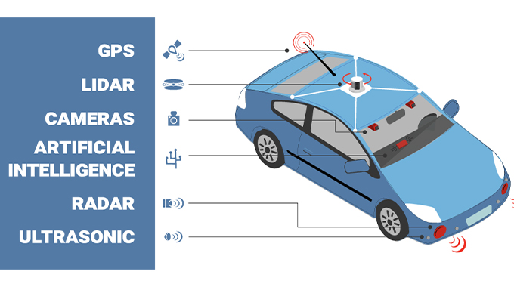

🔧 1. Perception (Sensing the Environment)
The car uses a combination of advanced sensor technologies to understand its surroundings:
Sensor | Function | Example
Cameras | Visual recognition (lanes, lights, signs, pedestrians) | Detects a stop sign
LIDAR (Light Detection and Ranging) | Creates a 3D map by measuring distances with lasers | Detects distance to a cyclist
Radar | Measures object speed and distance (through fog/rain) | Measures speed of nearby car
Ultrasonic Sensors | Short-range object detection | Used for parking
GPS & IMU (Inertial Measurement Unit) | Position tracking and orientation | Knows exact location on map
➡️ Result: The car builds a real-time model of the road, traffic, and environment.

🧠 2. Decision-Making (The Brain of the Car)
Once the car knows what's around it, it must decide:
- Should I slow down?
- Is it safe to change lanes?
- Should I stop at this intersection?
To answer these, the car uses multiple AI models and logic:
a. Perception AI
- Object detection (car, bike, human)
- Lane detection
- Sign & signal interpretation (e.g., green light = go)
b. Prediction AI
- Predicts what other road users will do (e.g., “Will this pedestrian cross?”)
c. Planning AI
- Chooses best path or lane
- Reroutes if road is blocked
d. Behavioral AI
- Obeys traffic laws
- Follows safety priorities (e.g., give way to ambulance)
e. Control System
- Translates high-level decisions into physical commands (steering angle, throttle, brake)

🏃‍♂️ 3. Acting (Moving the Vehicle)
Using actuators, the car executes its planned actions:
- Steering system → changes direction
- Throttle → controls speed
- Braking system → stops the car
- Indicators/lights → communicates with others
Example:
🚦 Light turns red → car decides to brake → brake actuator applies brakes → car stops.
💡 4. Learning and Improving Over Time
Self-driving cars often use machine learning and deep learning to:
- Train models on large datasets of driving scenarios
- Recognize objects more accurately (e.g., baby stroller vs. shopping cart)
- Adapt driving style based on past outcomes
Example Learning Technique: Reinforcement Learning
- Reward = safe and smooth drive
- Penalty = close calls, braking too hard
- Over time, the AI learns to maximize good driving behavior

🎯 Why a Self-Driving Car is a True AI Agent
Criteria | Explanation
Autonomy | Drives with no human control
Sensors | Understands the environment in real-time
Reasoning | Makes smart decisions based on rules and learning
Goal-oriented | Reaches destinations safely and efficiently
Learning Ability | Improves from past experiences, shared data
📘 Recommendation System
A Recommendation System is a type of Artificial Intelligence (AI) that helps users discover content, products, or services by suggesting items they are likely to prefer.
It uses user behavior, preferences, and item information to predict what the user might like next.
These systems are key tools in platforms like Netflix, Amazon, Spotify, and YouTube.
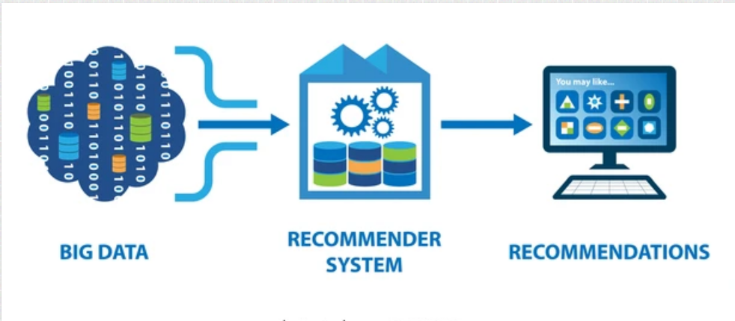
🧩 Types of Filters in Recommendation Systems
Recommendation systems mainly use the following three types of filtering techniques:

🔍 1. Content-Based Filtering
✅ Definition:
Recommends items based on a user’s past preferences and the attributes of the items.
🧠 How it Works:
- Builds a profile of the user's interests using item features (e.g., genre, brand, keywords).
- Compares new items with the user profile to find similar items.
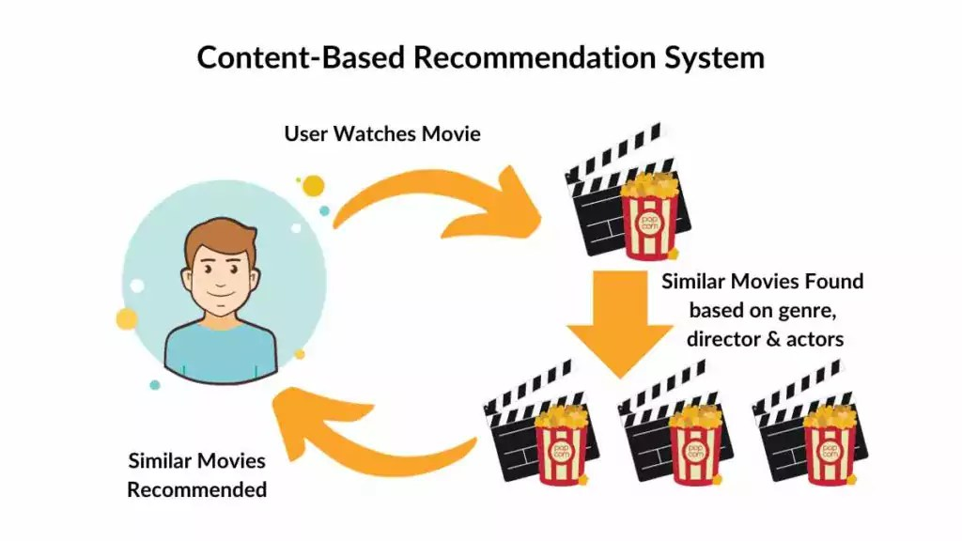
📦 Example:
A user watches sci-fi movies → The system recommends other sci-fi or space-related movies.
🛠️ Techniques Used:
- TF-IDF (Text analysis for keywords)
- Cosine similarity
- Feature vector comparison
✅ Advantages:
- Personalized to the user's tastes.
- Doesn’t require other users' data.
❌ Limitations:
- Cold start for new users with no history.
- Limited discovery — only similar items.

👥 2. Collaborative Filtering
✅ Definition:
Recommends items based on similarities between users or items, using crowd behavior and interaction data.
🧠 How it Works:
- Collects user-item interaction data (ratings, clicks, purchases).
- Finds users/items with similar behavior patterns.
🔄 Types:
- User-Based Filtering: Suggests items liked by similar users.
- Item-Based Filtering: Suggests items similar to those the user already liked.
📦 Example:
"People who watched this also watched..." or "Users like you liked..."
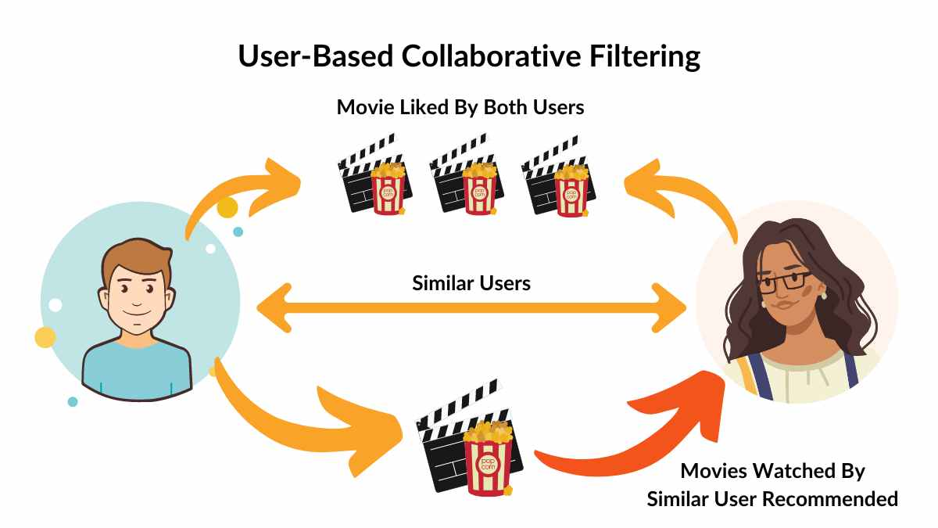
🛠️ Techniques Used:
- k-Nearest Neighbors (k-NN)
- Matrix factorization
- Singular Value Decomposition (SVD)
✅ Advantages:
- Provides unexpected discoveries.
- Learns from collective behavior.
❌ Limitations:
- Cold start (for new users or items).
- Sparse data can reduce accuracy.

🔗 3. Hybrid Filtering
✅ Definition:
Combines Content-Based and Collaborative Filtering to create a more accurate and flexible recommendation system.
🧠 How it Works:
- Merges both item features and user behavior.
- Can switch between models or combine their scores.
🔄 Hybrid Strategies:
- Weighted hybrid: Combine predictions from both models.
- Switching hybrid: Use one method based on context.
- Feature augmentation: Use output of one as input for the other.
📦 Example:
Netflix combines movie genres (content) with other users' viewing behavior (collaborative) to recommend content.
✅ Advantages:
- Overcomes cold start and sparsity issues.
- More diverse and accurate results.
❌ Limitations:
- More complex to develop.
- Higher computational cost.

🌍 Real-World Applications of Recommendation Systems
Domain | Application Example
E-Commerce | Amazon suggests products based on your purchases and browsing.
Streaming Media | Netflix, YouTube, and Hulu recommend shows and videos.
Music Platforms | Spotify or Apple Music recommend tracks and playlists.
Social Media | Facebook, TikTok, and Instagram recommend friends, pages, and reels.
Online Learning | Coursera, edX, and Udemy suggest courses based on interests.
News & Articles | Google News recommends articles based on your reading habits.
Job Portals | LinkedIn recommends jobs and connections based on user profile.

Recommendation systems are at the heart of many modern digital experiences. By using Content-Based, Collaborative, or Hybrid Filtering, they deliver personalized, relevant, and engaging content. These systems not only improve user satisfaction but also boost business outcomes in e-commerce, media, education, and more.

What is a Chatbot?
👉 A chatbot is a computer program that talks to users through text messages (and sometimes voice) to answer questions, give information, or help do tasks.
🧠 Think of it like:
A chatbot is like a smart helper that replies when you type:
“What time do you open?”
And it says: “We’re open from 9:00 AM to 6:00 PM.”
🔍 How does it work?
- You send a message (called input).
- The chatbot reads and understands what you said (using simple logic or AI).
- It replies with the best answer it can find.

✨ Types of Chatbots:
Type | Explanation | Example
Rule-Based Chatbot | Follows a fixed script. Only understands certain questions. | "Press 1 to check balance..."
AI-Based Chatbot | Understands more natural language. Can learn and improve. | ChatGPT, Google Bard
Hybrid Chatbot | Uses both rules and AI. More flexible. | A customer service chatbot that answers and sends you to a human if needed.

📱 Where do we use chatbots?
- Websites for FAQs
- Mobile apps for banking or shopping
- Messaging apps like Telegram, WhatsApp, or Facebook Messenger

🤖 What is a Conversational Agent?
👉 A conversational agent is a more advanced system that can talk with people through text, voice, or both, just like a real human conversation.
So a chatbot is one type of conversational agent, but not the only one!
🤔 What makes conversational agents smarter?
They don’t just answer one question at a time. They:
- Understand context (remember what you just said)
- Can handle long conversations
- May talk, not just type
- Can control devices or answer follow-up questions

Rule-Based Chatbots vs AI-Driven Conversational Agents
Aspect | Rule-Based Chatbots | AI-Driven Conversational Agents
Architecture | Predefined rules, decision trees, if-then logic | Neural networks, large language models (LLMs)
Learning | No learning; static knowledge base | Continuous learning from training data
Language Understanding | Keyword matching, pattern recognition | Deep semantic understanding, contextual comprehension
Response Generation | Template-based from predefined responses | Dynamic, generative responses
Flexibility | Limited to programmed conversation paths | Handles diverse topics and unexpected queries
Context Awareness | Minimal context retention | Maintains conversation context across exchanges
Development | Quick setup, manual rule programming | Requires ML expertise, longer training time
Accuracy | High accuracy within defined scope | Variable accuracy, may generate incorrect info
Resource Requirements | Low computational needs | High computational and memory requirements
Maintenance | High - manual rule updates needed | Lower - periodic retraining
Control | Complete control over responses | Limited control, "black box" behavior
Scalability | Limited, complex rule management | Highly scalable across domains

🧠 Technologies Used
Both systems may use:
- Natural Language Processing (NLP): To understand what humans say
- Machine Learning (ML): To learn from past conversations
- Speech recognition/synthesis: For voice agents like Alexa or Siri

Genetic Algorithm (GA)
✅ Definition:
A Genetic Algorithm is a search and optimization technique inspired by the process of natural selection and genetics in biology.
It is used in Artificial Intelligence and Machine Learning to find best solutions to complex problems — especially when the number of possible answers is too large for traditional methods.
The Three Main Genetic Operators in Genetic Algorithms
1. Selection
What it does: Chooses the fittest individuals from the current population to become parents for the next generation.
Purpose: Ensures that better solutions have a higher probability of passing their characteristics to offspring, driving the evolution toward better solutions.
How it works: Individuals with higher fitness scores are more likely to be selected for reproduction. Common methods include tournament selection, roulette wheel selection, and rank selection.

2. Crossover (Recombination)
What it does: Combines genetic material from two parent solutions to create one or more offspring.
Purpose: Creates new solutions by mixing the good characteristics of different parents, potentially producing even better solutions.
How it works: Takes parts from each parent and combines them. For example:
- Parent 1: [1,0,1,1,0,1,0]
- Parent 2: [0,1,0,1,1,0,1]
- Offspring:[1,0,1,1,1,0,1] (crossover at position 4)
3. Mutation
What it does: Introduces small random changes to individual solutions.
Purpose: Maintains genetic diversity in the population and prevents the algorithm from getting stuck in local optima by exploring new areas of the solution space.
How it works: Randomly alters small parts of a solution with low probability (typically 1-5%). For example:
- Before: [1,0,1,1,0,1,0]
- After: [1,0,1,0,0,1,0] (bit 3 flipped from 1 to 0)

Search Algorithm in AI
✅ Definition:
A Search Algorithm is a method used in Artificial Intelligence to find a solution to a problem by exploring possible options or paths.
In AI, we often face problems where we need to go from a starting point to a goal — like solving a puzzle, playing a game, or navigating a map. A search algorithm helps the AI figure out how to reach the goal step by step.

🧠 Simple Analogy:
Imagine you're in a maze and want to find the exit.
A search algorithm is like a smart way to explore the maze — trying different paths, remembering where you've been, and choosing the best way out.

📦 Types of Search in AI:
1. Uninformed (Blind) Search
These algorithms have no extra knowledge about the goal — they just search blindly.
a) Breadth-First Search (BFS)
- Explores all paths level by level
- Finds the shortest path, but can be slow
- Uses a queue (FIFO)
Example: Finding the shortest path in a map.
b) Depth-First Search (DFS)
- Goes deep into one path before backtracking
- Uses less memory, but can get lost
- Uses a stack (LIFO)
Example: Solving a maze recursively.
c) Uniform Cost Search (UCS)
- Chooses path with lowest cost (like fuel, time, etc.)
- Guarantees optimal solution
Example: GPS finds path with the least travel time.

2. Informed (Heuristic) Search
These use extra information (heuristics) to make better choices.
a) Greedy Best-First Search
- Uses a heuristic function to pick the nearest-looking goal
- Fast, but not always optimal
Example: Like running straight toward the exit in a maze.
b) A* Search (A-Star)
- Combines cost so far (g) and estimated cost to goal (h)
- Fast and optimal — one of the best general-purpose algorithms
Example: Used in Google Maps, games, and robotics.

The following links contain useful materials that will help you understand the topics better.
https://medium.com/data-science/what-is-machine-learning-how-i-explain-the-concept-to-a-newcomer-d96f35a5c4f3
https://medium.com/edureka/machine-learning-tutorial-f2883412fba1
https://medium.com/data-science/recommender-systems-a-complete-guide-to-machine-learning-models-96d3f94ea748
https://medium.com/@adityamhaske711/case-study-self-driving-cars-1e837ad4c872
https://www.geeksforgeeks.org/artificial-intelligence/large-language-model-llm/
https://medium.com/geekculture/introduction-to-genetic-algorithm-d417119040b7

